Andrew Kozempel

Professor Avanzato

CMPSC 497

5 September 2023

**Homework 1B**

**Part #1: Displaying and Analyzing an Image**

**Objective:** To display, analyze, and manipulate a MATLAB sample image using various MATLAB tools and functions.

**MATLAB Script:**

| **%{ Andrew Kozempel CMPSC 497 Fall 2023 HW #1A Intro to MATLAB Statistics: Part 1 %}  % PART 1 - peppers.png  % 1 - read/display im = imread('peppers.png'); imshow(im);  % 2 - dimensions fprintf(['peppers.png Dimensions:\n\tRows: %d\n\tColumns %d' ...  '\n\tPlanes: %d\n'], size(im));  % 3 - pixel regions imtool(im);  % 4 - red plane red = im(:, :, 1); figure; imshow(red); title('Red Plane');  % 5 - blue plane blue = im(:, :, 2); figure; imshow(blue); title('Blue Plane');  % 6 - green plane green = im(:, :, 3); figure; imshow(green); title('Green Plane');  % 7 - grayscale gray = rgb2gray(im); [gray_rows, gray_cols] = size(gray); figure; imshow(gray); title('Grayscale');  % 7 - questions fprintf('\nGrayscale Pixel Range:\n\t%d to %d\n', min(min(gray)), max(max(gray))); fprintf('Grayscale Dimensions:\n\t%d Rows x %d Columns\n', size(gray));  % 8 - min, max, mean pixel vals minimum = min(min(gray)); maximum = max(max(gray)); average = mean(mean(gray)); fprintf(['Grayscale Image Stats:\n\tMinimum: %d\n\tMaximum: %2f' ...  '\n\tMean: %d'], minimum, maximum, average);  % 9 - Histogram figure; imhist(gray); title('Grayscale Histogram'); xlabel('Pixel Intensity'); ylabel('Frequency');  % 10 - top half figure; gray_top_half = gray(1:gray_rows/2, :); imshow(gray_top_half); title('Top Half of Grayscale');  % 11 - right half figure; gray_right_half = gray(:, gray_cols/2+1:gray_cols); imshow(gray_right_half); title('Right Half of Grayscale');  % 12 - binary gray_bin = imbinarize(gray); figure; imshow(gray_bin); title('Binary Grayscale'); fprintf('\n\nBinary Grayscale Pixel Range:\n\t%d to %d\n', ...  min(min(gray_bin)), max(max(gray_bin)));  % 13 - reduce OG im by .50 im_reduced = imresize(im, 0.5); figure; imshow(im_reduced); title('Reduced Original Image (50% Reduced)');  % 14 - resize 200x200 im_resized = imresize(im, [200,200]); figure; imshow(im_resized); title('Resized Original Image (200x200)');  % print original, reduced, resized dimensions to compare fprintf(['\nOriginal Image Dimensions:\n\t%d Rows x %d Columns ' ...  'x %d Planes\n'], size(im)); fprintf(['Reduced Image Dimensions:\n\t%d Rows x %d Columns ' ...  'x %d Planes\n'], size(im_reduced)); fprintf(['Resized Image Dimensions:\n\t%d Rows x %d Columns ' ...  'x %d Planes\n'], size(im_resized));** |
| --- |

**Results:**

| **OUTPUT** |
| --- |
| **peppers.png Dimensions:**  **Rows: 384**  **Columns 512**  **Planes: 3**  **Grayscale Pixel Range:**  **8 to 255**  **Grayscale Dimensions:**  **384 Rows x 512 Columns**  **Grayscale Image Stats:**  **Minimum: 8**  **Maximum: 255.000000**  **Mean: 8.165938e+01**  **Binary Grayscale Pixel Range:**  **0 to 1**  **Original Image Dimensions:**  **384 Rows x 512 Columns x 3 Planes**  **Reduced Image Dimensions:**  **192 Rows x 256 Columns x 3 Planes**  **Resized Image Dimensions:**  **200 Rows x 200 Columns x 3 Planes** |

1. 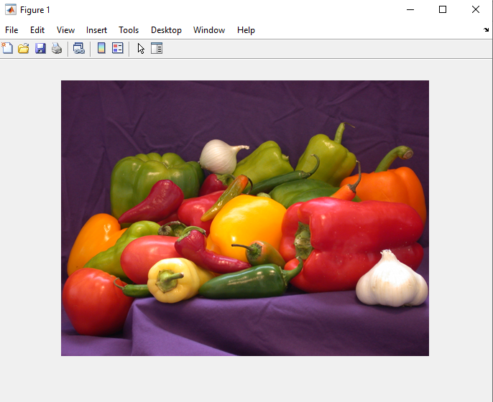
2. **Dimensions:** 384 Rows x 512 Columns x 3 Planes
3. **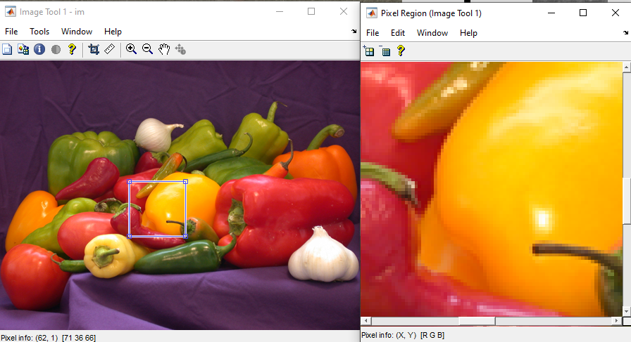  
   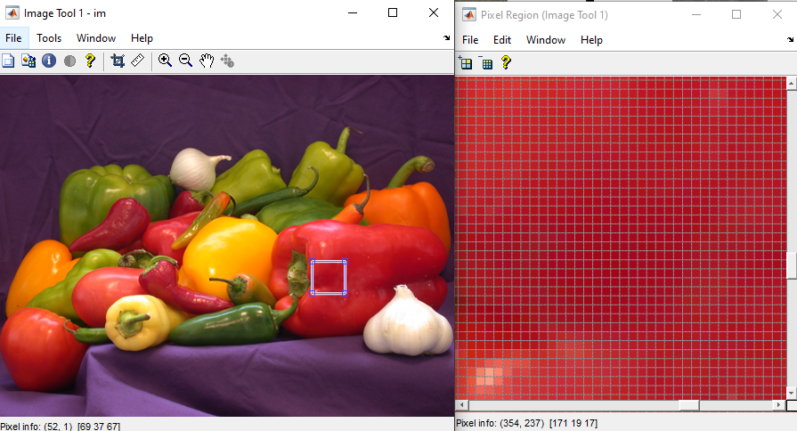**
4. 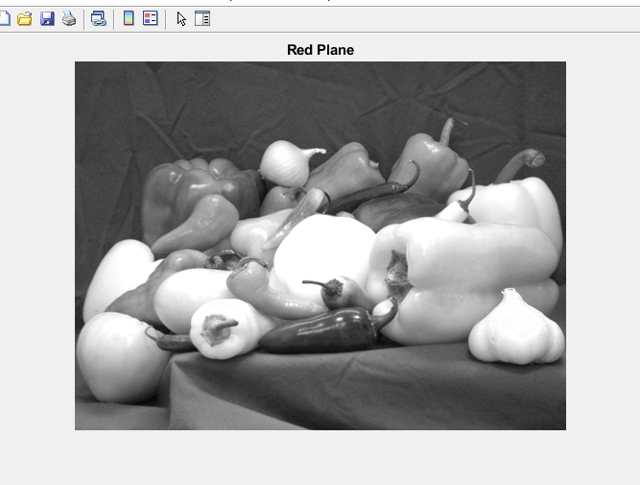
5. 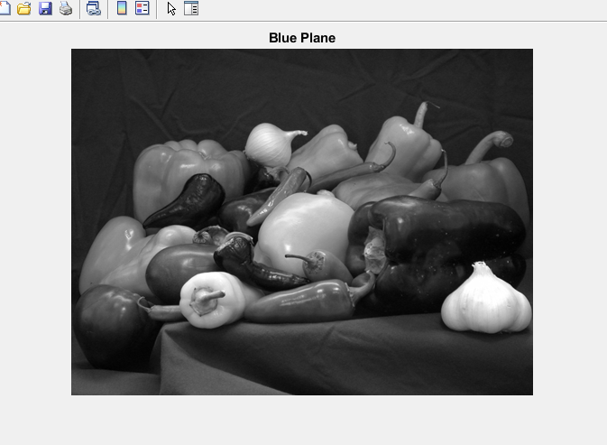
6. 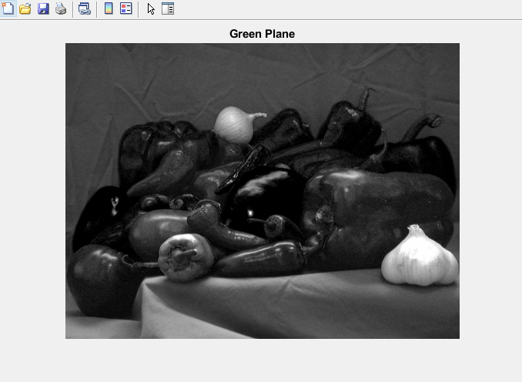
7. **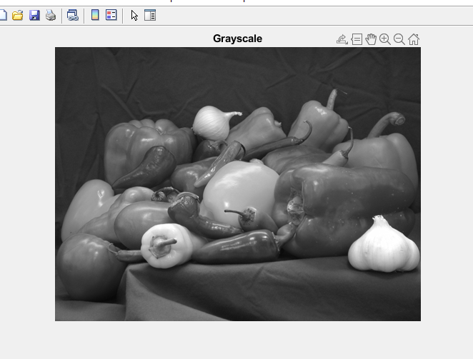  
     
   Questions:  
   What is the range of individual pixels?** 8 to 255 **How many planes does an intensity (grayscale) image have?** Only 1. Shades of gray are presented in a single plane. **What are the dimensions of the grayscale image?** 384 Rows x 512 Columns
8. **Grayscale Image Stats:** Minimum: 8  
    Maximum: 255.000000  
    Mean: 8.165938e+01
9. **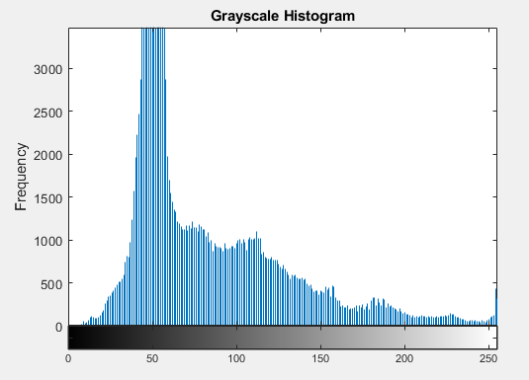  
     
   Can you interpret this plot – what does it mean?** It is showing the distribution of the different pixel values and how much of each is in the image. (not sure why x axis label is not showing up)
10. 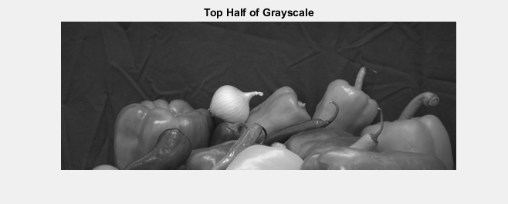
11. 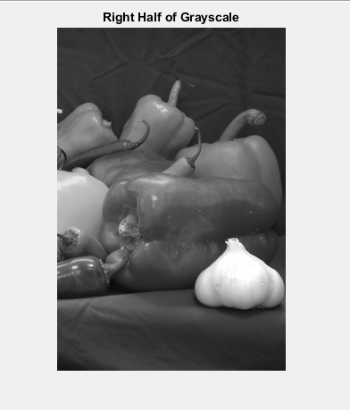
12. **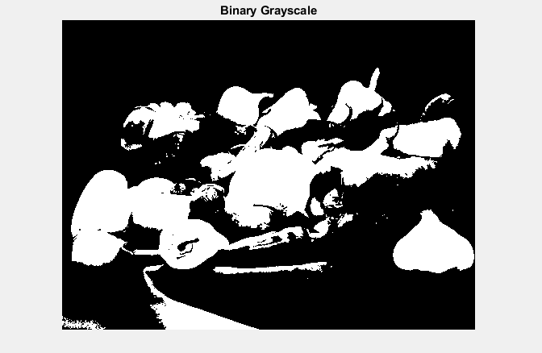  
      
    What is the range of values for the pixels in a binary image?** 0 to 1
13. **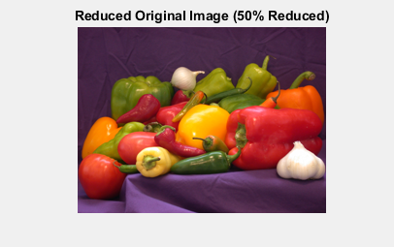  
      
    Size after reduction?** 192 rows x 256 columns **Is there any distortion?** No, the aspect ratio is preserved.

**Part #2: Displaying and Analyzing my own Image**

**Objective:** To display, analyze, and manipulate my own image using various MATLAB tools and functions.

**MATLAB Script:**

| **% PART 2 - my_image.png  % 1 - read/display im2 = imread('my_image.png'); imshow(im2);  % 2 - dimensions fprintf(['my_image.png Dimensions:\n\tRows: %d\n\tColumns %d' ...  '\n\tPlanes: %d\n'], size(im2));  % 3 - pixel regions imtool(im2);  % 4 - red plane red2 = im2(:, :, 1); figure; imshow(red2); title('Red Plane 2');  % 5 - blue plane blue2 = im2(:, :, 2); figure; imshow(blue2); title('Blue Plane 2');  % 6 - green plane green2 = im2(:, :, 3); figure; imshow(green2); title('Green Plane 2');  % 7 - grayscale gray2 = rgb2gray(im2); [gray_rows2, gray_cols2] = size(gray2); figure; imshow(gray2); title('Grayscale 2');  % 7 - questions fprintf('\nGrayscale 2 Pixel Range:\n\t%d to %d\n', min(min(gray2)), max(max(gray2))); fprintf('Grayscale 2 Dimensions:\n\t%d Rows x %d Columns\n', size(gray2));  % 8 - min, max, mean pixel vals minimum2 = min(min(gray2)); maximum2 = max(max(gray2)); average2 = mean(mean(gray2)); fprintf(['Grayscale 2 Image Stats:\n\tMinimum: %d\n\tMaximum: %2f' ...  '\n\tMean: %d'], minimum2, maximum2, average2);  % 9 - Histogram figure; imhist(gray2); title('Grayscale 2 Histogram'); xlabel('Pixel Intensity'); ylabel('Frequency');  % 10 - top half figure; gray_top_half2 = gray2(1:gray_rows2/2, :); imshow(gray_top_half2); title('Top Half of Grayscale 2');  % 11 - right half figure; gray_right_half2 = gray2(:, gray_cols2/2+1:gray_cols2); imshow(gray_right_half2); title('Right Half of Grayscale 2');  % 12 - binary gray_bin2 = imbinarize(gray2); figure; imshow(gray_bin2); title('Binary Grayscale 2'); fprintf('\n\nBinary Grayscale 2 Pixel Range:\n\t%d to %d\n', ...  min(min(gray_bin2)), max(max(gray_bin2)));  % 13 - reduce OG im by .50 im_reduced2 = imresize(im2, 0.5); figure; imshow(im_reduced2); title('Reduced Original Image 2 (50% Reduced)');  % 14 - resize 200x200 im_resized2 = imresize(im2, [200,200]); figure; imshow(im_resized2); title('Resized Original Image 2 (200x200)');  % print original, reduced, resized dimensions to compare fprintf(['\nOriginal Image 2 Dimensions:\n\t%d Rows x %d Columns ' ...  'x %d Planes\n'], size(im2)); fprintf(['Reduced Image 2 Dimensions:\n\t%d Rows x %d Columns ' ...  'x %d Planes\n'], size(im_reduced2)); fprintf(['Resized Image 2 Dimensions:\n\t%d Rows x %d Columns ' ...  'x %d Planes\n'], size(im_resized2));** |
| --- |

**Results:**

| **OUTPUT** |
| --- |
| **my_image.png Dimensions:**  **Rows: 978**  **Columns 1170**  **Planes: 3**  **Grayscale 2 Pixel Range:**  **0 to 65407**  **Grayscale 2 Dimensions:**  **978 Rows x 1170 Columns**  **Grayscale 2 Image Stats:**  **Minimum: 0**  **Maximum: 65407.000000**  **Mean: 3.145531e+04**  **Binary Grayscale 2 Pixel Range:**  **0 to 1**  **Original Image 2 Dimensions:**  **978 Rows x 1170 Columns x 3 Planes**  **Reduced Image 2 Dimensions:**  **489 Rows x 585 Columns x 3 Planes**  **Resized Image 2 Dimensions:**  **200 Rows x 200 Columns x 3 Planes** |

1. 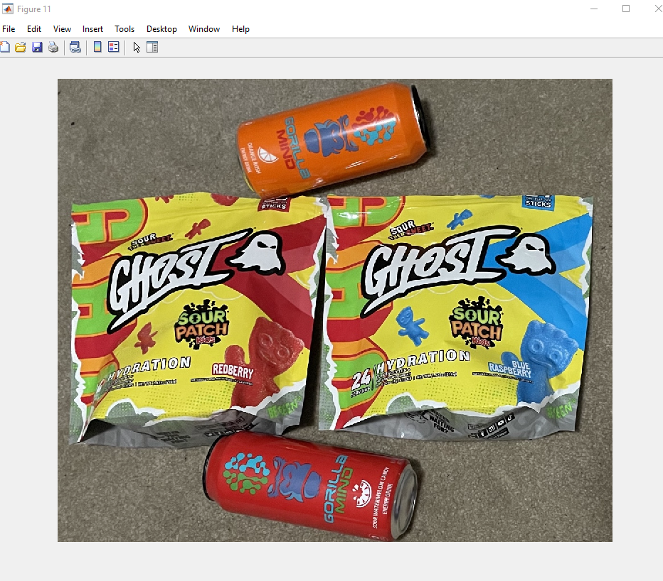
2. **Dimensions:** 978 Rows x 1170 Columns x 3 Planes
3. **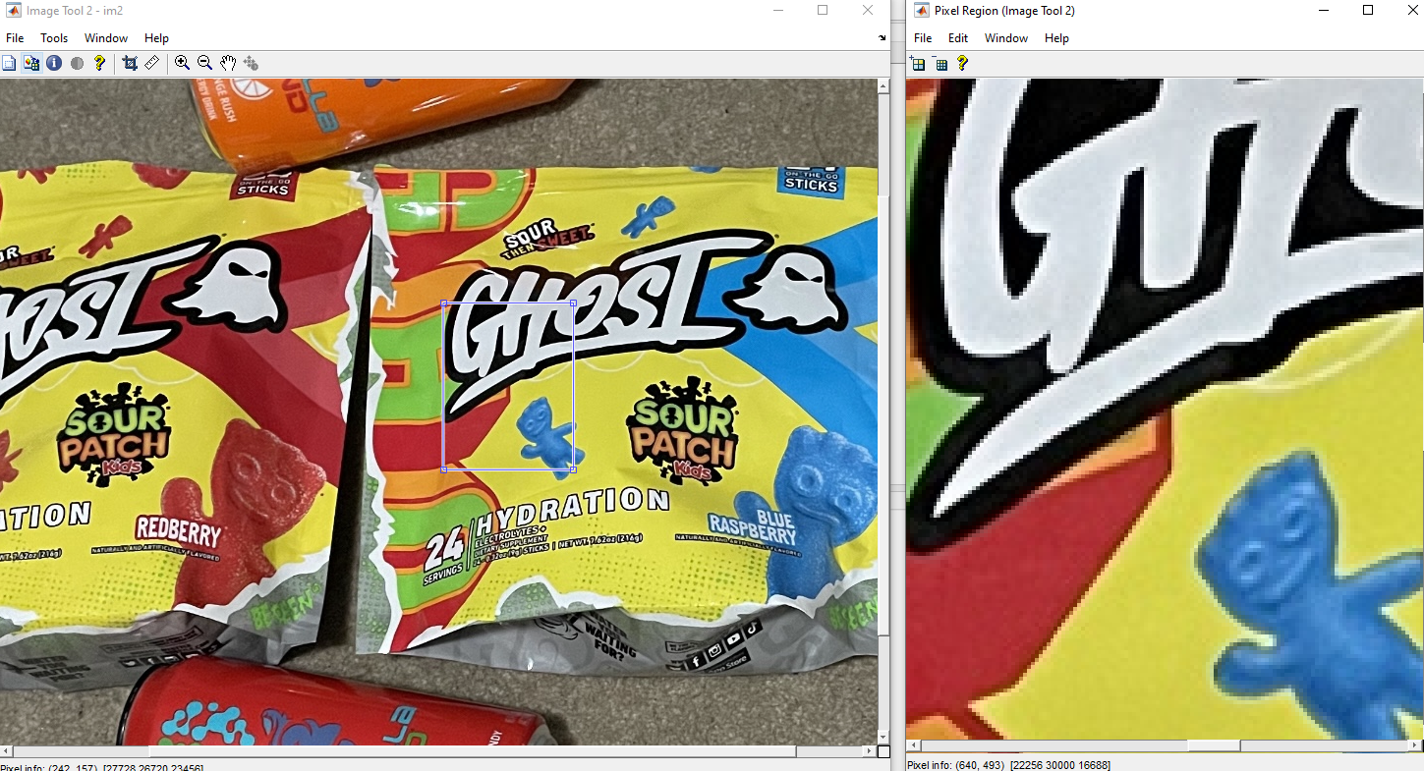  
   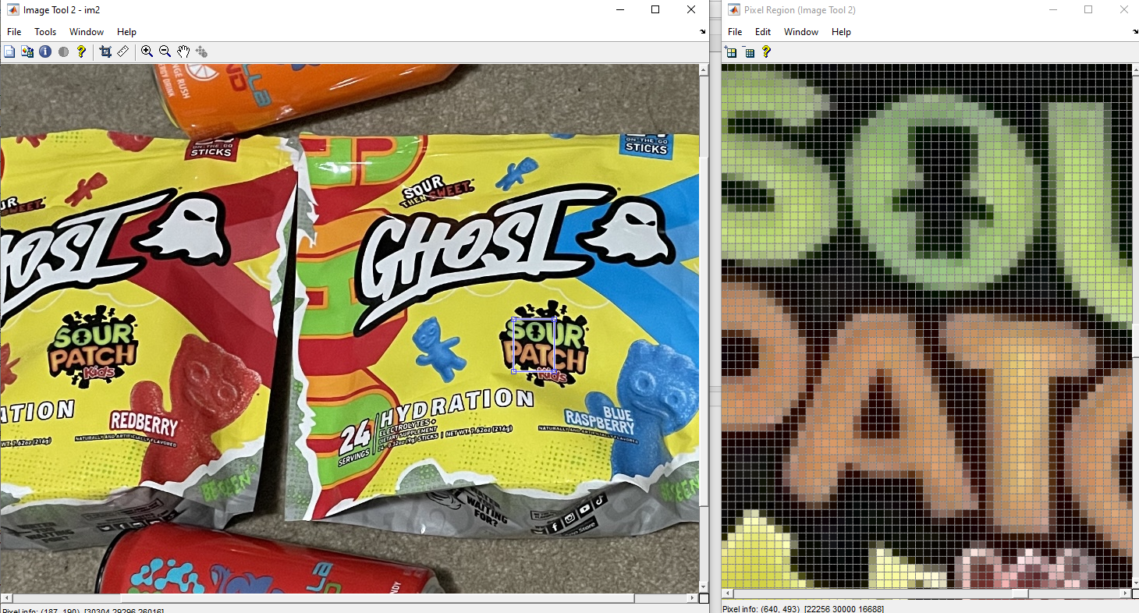**
4. 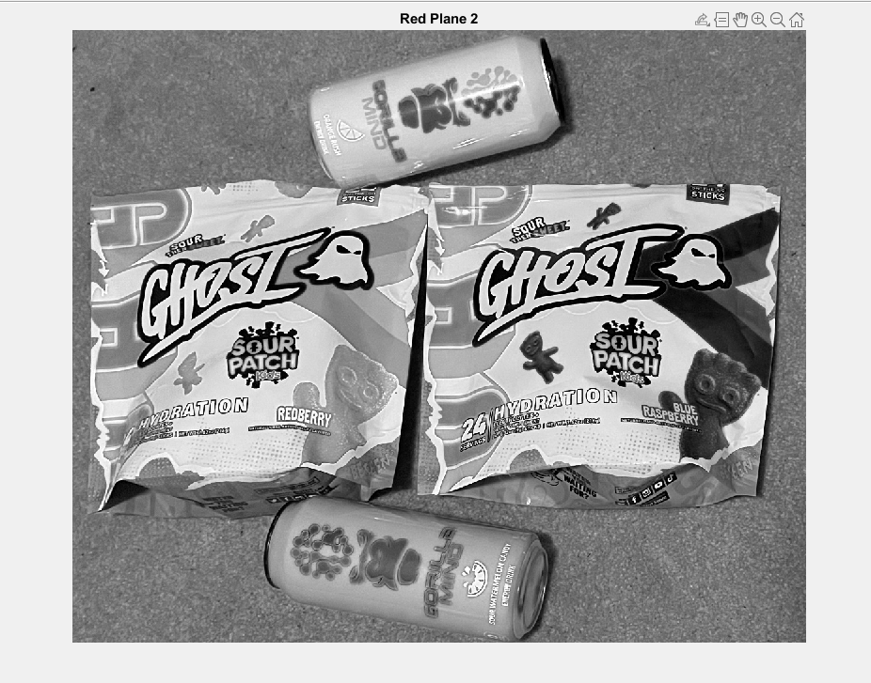
5. 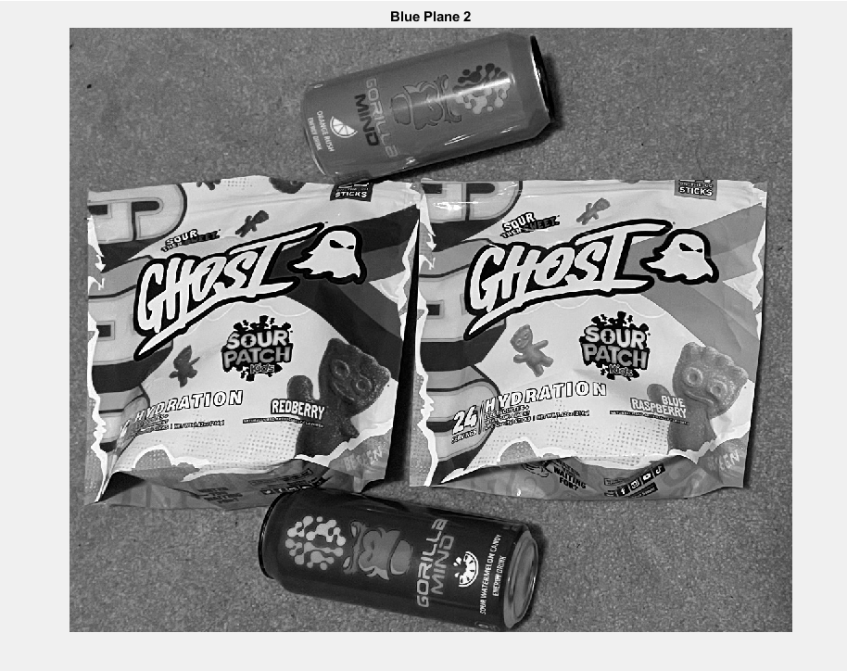
6. 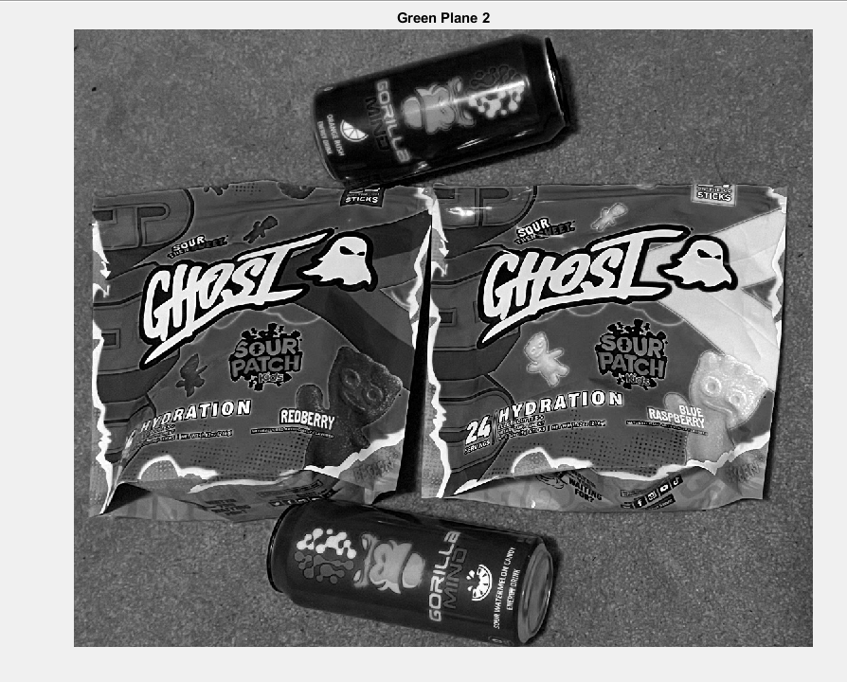
7. **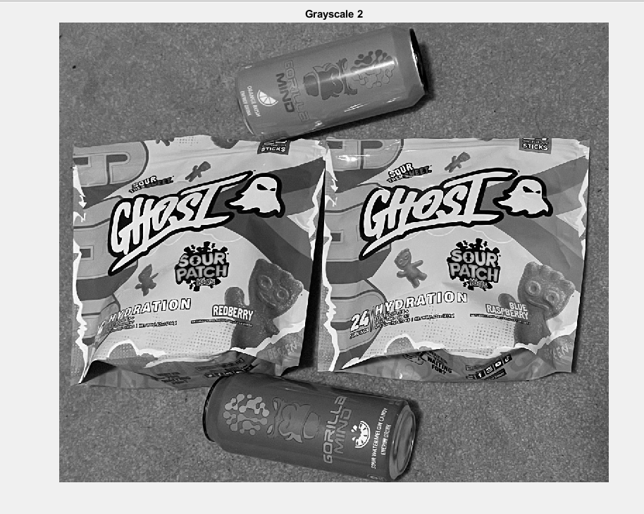  
     
   Questions:  
   What is the range of individual pixels?** 0 to 65407 **How many planes does an intensity (grayscale) image have?** Only 1. Shades of gray are presented in a single plane. **What are the dimensions of the grayscale image?** 978 Rows x 1170 Columns
8. **Grayscale Image Stats:** Minimum: 0  
    Maximum: 65407.000000  
    Mean: 3.145531e+04
9. **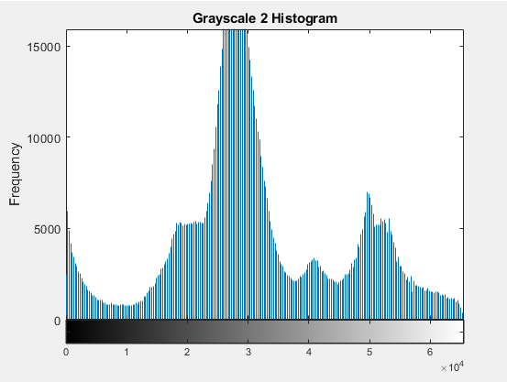  
     
   Can you interpret this plot – what does it mean?** It is showing the distribution of the different pixel values and how much of each is in the image. (not sure why x axis label is not showing up)
10. 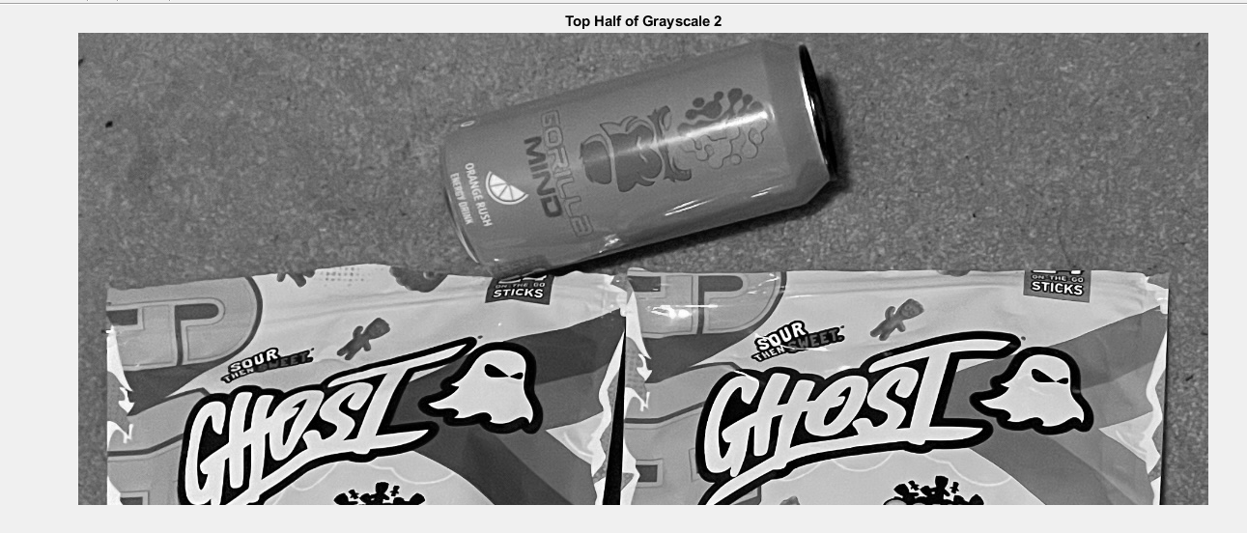
11. 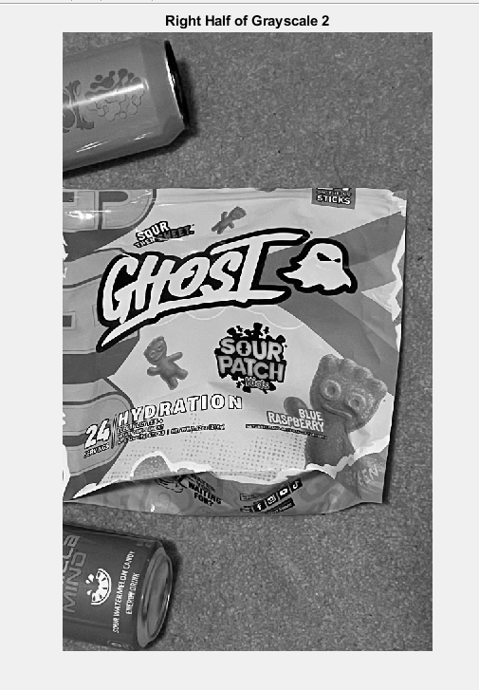
12. **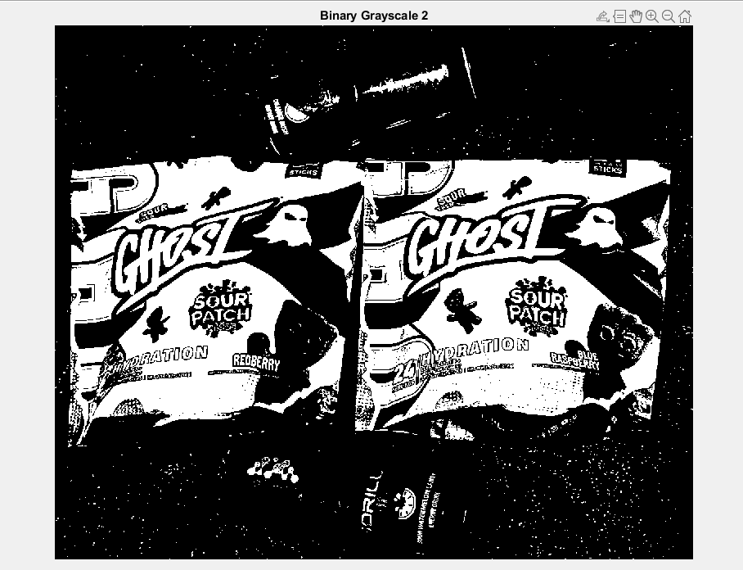  
      
    What is the range of values for the pixels in a binary image?** 0 to 1
13. **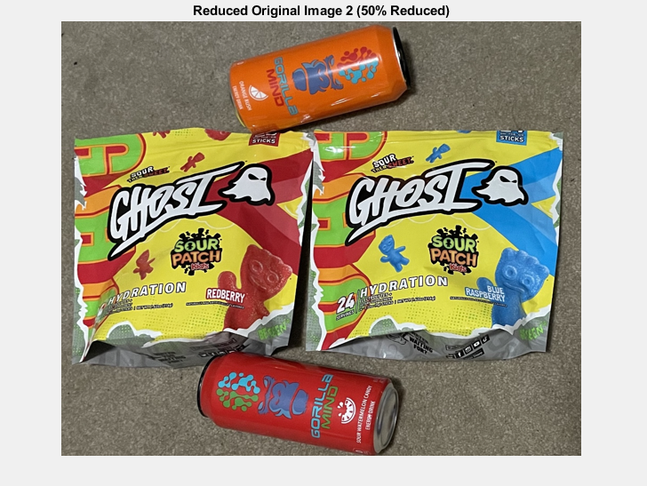  
      
    Size after reduction?** 489 rows x 585 columns **Is there any distortion?** No, the aspect ratio is preserved.
14. **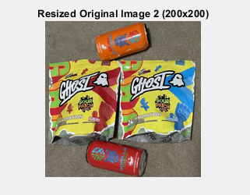  
      
    Is there any distortion?** Yes, the aspect ratio was not preserved.